**NCCS Higher Secondary School**

**(NCCS)**

**Paknajol, Kathmandu**

A Project Report

On

**"Ozzy Futsal"**

As per partial fulfillment of requirement of NEB in +2 program

**Submitted By: Submitted To:**

**Prabin Buddhacharya Sanjay Phuyal**

**Class: 11 ‘J’ Ujjwal Maharjan**

**(Computer Sir)**

**Date: 22 Feb, 2018**

**Letter of certificate**

This is to verify that **Mr. Prabin Buddhacharya** student of NCCS Higher Secondary School, Grade: XI, Section: J, Roll No:20 has duly completed html Project on the topic “Ozzy futsal” using HTML under the guidance of **Mr.Sanjay Phuyal** and **Mr.Ujjwal Maharjan** as for the requirement for Class. XI NEB Exam.

Date of Submission: 22 feb 2018

NCCS Registration NO: 5202

**DECLARATION**

I herby, declare that the work reported in this report entitled **“Ozzy Futsal”** submitted to the Computer Science Department of NCCS Higher Secondary School is my original work done in the form of partial fulfillment of the requirements of NEB for the +2, under the supervision of **Mr. Sanjay Phuyal and Mr. Ujjwal Maharjan**.

Signature

Students Name: Prabin Buddhacharya

Roll No: 20

NCCS Registration No: 5202

Date: 22 Feb, 2018

**ACKNOWLEDGEMENTS**

This report entitled **"Ozzy Futsal"** is prepared in the partial fulfillment of the requirements of NEB for the +2 level. It is the result of cooperation and support of my teachers and my friends. Most importantly, I would like to express my sincere thanks to my teacher **Mr.Sjanjay Phuyal** and Head of Computer Science Department **Mr. Dinesh khadka** for providing suggestion and guidance for preparing this report. Your precious has certainly helped me in giving the meaning to my project work.

Students Name:Prabin Buddhacharya

Kathmandu, Nepal

Date: 22Feb, 2018

**Abstract**

This program report aims at building web page using HTML tags. This project has been prepared for the partial fulfillment of requirement of NEB in +2 program. This program is done on the primary data collected from football association. This project is related to futsal.

This report mainly focuses on physical fitness of football and futsal player. It provides fitness to body and entertainment to peoples. This provides a lot of benefits for the organization and people. This report contains different html tags and C++ to prepare a best web page for futsal page. People can make online booking through prepared web page.

The web page has made people easy to book the games for futsal and their game. So, this futsal page is really a well designed and well interface web page.

Contents

Chapter 1: Introduction to computer 1

1.1: Introduction to Project 1

1.2 Importance 1

1.2 Objectives 1

Chapter 2: Introduction to HTML 2

2.1 About HTML 2

2.2 Types of tags 2

2.3 Basic Structure of HTML: 3

2.4 Character formatting 3

Heading 4

Text formatting 5

Font 6

Horizontal Ruler: 6

Marquee: 6

2.5 list 7

Ordered list: 7

Unordered list: 7

Description list: 7

Nested list 7

2.6 Hyper link 8

Different types of link: 9

External link: 9

Internal link: 9

Mail link: 10

2.7 table 10

2.8 Frame and form 11

Frame 11

Form: 12

2.9 CSS 12

Inline style: 12

Internal style sheet: 13

External style sheet: 14

CHAPTER 3: INTRODUCTION TO PROJECT 16

3.1 Introduction 16

3.2 SCOPE 16

3.3 LIMITATION 16

Chapter 4: HTML Coding and Output 17

HOME 17

GALLERY 19

ABOUT US 23

ONLINE BOOKING 26

CONCLUSION: 30

## LIST OF FIGURES

Figure 1 –Home page 1 19

Figure 2 –Home page 2 19

Figure 3 –Gallery 1 22

Figure 4 –Gallery 2 22

Figure 5 –Gallery 3 23

Figure 6 –About us 1 25

Figure 7 – About us 2 26

Figure 8 Booking 1 28

Figure 9 – Booking 2 29

# Chapter 1: Introduction to computer

## 1.1: Introduction to Project

This project is made on the topic ‘Ozzy Futsal’. It describe about the futsal and about its advantages. It’s coding is done on HTML. People visit futsals to enjoy and play footballs. With the help of this webpage people can get information about futsal, people can know the recent activities of futsal and people can also book futsal online for their games.

## 1.2 Importance

With the help of this project student can learn about the coding (HTML). Students also can learn to make report.

## 1.2 Objectives

It helps student to learn more about the coding (HTML). Students also can learn about making projects**.**

# Chapter 2: Introduction to HTML

## 2.1 About HTML

The inventor of World Wide Web (Tim Berners) also was the person who developed HTML in the 1990’s. The web is based on that language. HTML stands for Hyper Text Markup Language. It is a language for describing web pages. It is a language used for creating web pages containing text, graphics, animation, sound, video and interactive elements.

It is a standard set of codes, called tags, used to format all web pages. The HTML provides a set of rules defining the way tags can be used and combined. It is a document containing HTML tags and plain text. Learning the HTML means learning the tags and rules.

HTML elements forms the buildings blocks of all websites. HTML allows images and objects to be embedded and can be used to create interactive forms. It provides a means to create structured documents by denoting structural semantics for texts such as headings, paragraphs, lists, links, quotes and other items.

## 2.2 Types of tags

The HTML tags are the keywords surrounded by angle brackets; used to describe the content of web page. It has three sections:

1. Tag name
2. Attributes
3. 2.2 Types of tags Value of attributes

Example:

<BODY bgcolor=”#ccffcc” text= ”green”>

(In this example the BODY is the tag name, bgcolor and text are the attributes and the green are the values.)There are two types of tags:

1. Paired tags :

It has two parts the opening and the closing.

* An opening tag is a tag that indicates the start of the HTML commands. It always begins with <….>.
* A closing tag is a tag that indicates the end of the HTML commands. It always begin with </…..>.

1. Singular tags:

It is a single type of tag that does not have any ending tag. It issues an HTML command without enclosing any text in the page.

Example: <br>, <hr> etc.

## 2.3 Basic Structure of HTML:

<HTML>

<HEAD>

<TITLE>………</TITLE>

</HEAD>

<BODY>

………………………………

……………………………..

</BODY>

</HTML>

Attributes used in body tag:

|  |  |  |
| --- | --- | --- |
| **Attributes** | **Values** | **Description** |
| Bgcolor | Color name/ color code | To specify the background color of webpage |
| Background | url of image | To specify image file background image of page |
| Text | Color name/ color code | To specify the color of text in a webpage |
| Link | Color name/ color code | To specify the color of hyper link before clicking |
| Alink | Color name/ color code | To specify the color of active link |
| Vlink | Color name/ color code | To specify the color of visited link |
| Topmargin | Number in pixel | To specify top margin of page |
| Bottommargin | Number in pixel | To specify bottom margin of page |

## 2.4 Character formatting

Paragraph

The <p> tag is used to specify the paragraph. When the user uses this tag the computer automatically adds a blank line before and after writing a paragraph.

|  |  |  |
| --- | --- | --- |
| **Attribute** | **Value** | **Description** |
| Align | Left/right/center | To specify the alignment of the paragraph |

{Note: If no alignment is defined for the paragraph then by default the paragraph comes on the left side.}

Example:

<Html>

<Head>

<Title>…..</Title>

</Head>

<Body>

<p align=”right/left/center”>

……………………………………………………

…………………………………………………

.</p>

</body>

</html>

## Heading

It is a simple form of text formatting according to heading’s level. It contains of six elements (H1 to H6). To get the biggest heading <H1> tag is used in front of the text the user desires to make as a heading and ends it with </H1> tag; likewise if a smaller heading is needed then <H2>…</H2> tag is used and for even smaller and smaller headings <H3>/<H4>/<H5>.

To create the smallest heading <H6> tag is used.

Example:

<html>

<head>

<title> ….</title>

</head>

<body bgcolor=”#ccffcc” text=”red”>

<h1>…..</h1>

<h2>…..</h2>

<h3>……</h3>

<h4>…….</h4>

<h5>……..</h5>

<h6>……..</h6>

</body>

</html>

## Text formatting

There are various types of formatting tags to display html tags in different forms and they are as follows:

|  |  |
| --- | --- |
| Tag | Description |
| <b> | Defines bold text |
| <i> | Defines italicized text |
| <em> | Defines emphasized text |
| <small> | Defines smaller text |
| <strong> | Defines important text |
| <sub> | Defines subscript |
| <sup> | Defines superscript |
| <u> | Defines underlined text |
| <strike> | Defines a strike through text |
| <tt> | Defines teletype text |
| <small> | Defines font size one point smaller |
| <big> | Defines font size one point bigger |
| <abbr> | Defines an abbreviation |
| <q> | Defines inline quotation |
| <blockquote> | Defines a section that is quoted from another source |
| <bdo> | Defines the text direction. |
| <dfn> | Defines the definition term |
| <cite> | Defines citation |
| <acronym> | Defines acronym |
| <address> | Defines an address element |
| <pre> | Defines preformatted text |

## Font

<Font> this tag is used to specify the font color, size and name.

|  |  |  |
| --- | --- | --- |
| Attributes | Values | Description |
| Face | Font name | To specify the font of text |
| Color | Color name/color code | To specify the color of text |
| Size | 1 to 7 | To specify the font size, default is 3. |

## Horizontal Ruler:

<Hr> tag defines a horizontal ruler. It is an empty tag. It’s attributes are:

|  |  |  |
| --- | --- | --- |
| Attributes | Values | Description |
| Size | Number in pixels | To specify the thickness of line |
| Width | % or number in pixel | To specify the width of line |
| Align | Left/right/center | To specify alignment |
| Color | Color code/ color name | To specify the color of line |

## Marquee:

<marquee> tag is used to animate(scroll) text or image in different direction with different behaviors.

|  |  |  |
| --- | --- | --- |
| Attributes | Values | Description |
| Direction | Left/right/up/down | To specify the direction of scroll |
| Behavior | Scroll/slide/alternate | To specify the marquee behavior |
| Scrollamount | Number in pixel | To specify scroll amount in pixel |
| Bgcolor | Color name/color code | To specify background color for marquee |
| Loop | Number or infinite | To specify number of repetition |

Example:

<marquee direction=”right” behavior=”alternate” loop=”infinite” scrollamount=”50” bgcolor=”#ccffcc”>……………..</marquee>

## 2.5 list

Lists are used to group related pieces of information together, so they are clearly associated with each other and are easy to read. The html has three types of list:

1. Ordered list
2. Unordered list
3. Description list

### Ordered list:

It is a type of list that is used to group a set of related items in a specific order. This is defined in html by <ol>…….</ol> tag. Every item in this list begins with a sequence number. Each item is inserted with <li>…</li> tag that creates a line break and inserts a number at the beginning.

|  |  |  |
| --- | --- | --- |
| **Attributes** | **Values** | **Description** |
| Type | 1/i/I/a/A | Type of numbered list. |
| Start | Number | Starting value of the numbering. |

### Unordered list:

It can be also known as bulleted list. This list groups a set of related items together but does not list it in a particular order. It is defined by <ul>…..</ul> tag. In this list every item begins with a bulletin mark in the beginning.

|  |  |  |
| --- | --- | --- |
| **Attributes** | **Values** | **Descriptions** |
| Type | Disc/circle/square | Used to specify the type of bulleted list. |

### Description list:

It is a type of list that is used to display name/values pairs such as their terms and definitions etc. This list is different from other kinds of list, as they use name and values instead of list items. Description list is defined by <dl>….</dl> elements. The <dl> tag is used with conjunction <dt></dt> to define names/terms and <dd></dd> to define <terms/values>.

# Nested list

A nested list is a list occurring in the bound of another list nesting the new list inside the original.

Example:

<html>

<head>

<title>……</title>

</head>

<body>

<b>classificationsoftware</b>

<ol>

<li>…..</li>

<ol type=”a” start=”3”>

<li>……</li>

</ol>

<li>……</li>

<ul type=”square”>

<li>….</li>

<li>…..</li>

</ul>

</ol>

</body>

</html>

## 2.6 Hyper link

Hyperlink is a component of web that is used to jump from one piece of information to another. The piece of information can either be of the same page or on a different web page. When the cursor is moved over to a link then the cursor turns into a small hand.

An anchor<a> element is used to define a link and its important attribute is the href that indicates the link’s destination.

|  |  |  |
| --- | --- | --- |
| **Attributes** | **Values** | **Descriptions** |
| Href | url of webpage or name of bookmark. | To indicate the linked destination |
| Target | _blank  _parent  _self  _top | To specify where to open the linked document. |
| Name(or id) | Section name(user defined) | For specifying specific point on a page. |

# Different types of link:

### External link:

It is a link used to jump to different webpages or websites.

Example:

<html>

<head>

<title> external link</title>

</head>

<body alink=”green” link=”red” vlink=”brown”>

<ul>

<li><a href=”<http://www.google.com>”>[www.google.com](http://www.google.com)</li>

</ul>

</body>

</html>

### Internal link:

It is a link used to jump from one part of page to another part of the same page. For this a location on a page is marked by using name attribute in a <a> tag.

Example:

<html>

<head>

<title> internal link</title>

</head>

<body>

<a name=”movie”></a>

<a href=”#book”>click here to go to books </a>

<pre>

3 iditos

</pre>

<a name=”books”></a>

<a href=”#movie”> click here to go to movie </a>

<pre>

Fault in our stars

</pre>

</body>

</html>

### Mail link:

It is used to link e-mail address. The value of href attribute for mail link is <mailto:emailsddress>

Example:

<a href=” <mailto:canon.04@gmail.com>”>[canon.04@gmail.com](mailto:canon.04@gmail.com)</a>

## 2.7 table

Table is a two dimensional structure with rows and columns. <table>…….</table> tag defines the table. In a table <tr> tag divides the table into rows ,<td> tag divides the row in data cells and the <th> tag defines the header information of the table. To merge two or many rows together in a table rowspan is used likewise for the column colspan is used.

Example:

<html>

<head> <title> table <title> </head>

<body>

<table border=”1”>

<caption align=”top”>…….</caption>

<tr>

<throwspan=2>…. </th>

<throwspan=2>…..</th>

<thcolspan=2>……</th>

</tr>

<tr>

<th>…</th><th>…..</th>

</tr>

<tr>

<td>…..</td>

<td>…..</td>

</tr>

</table>

</body>

</html>

## 2.8 Frame and form

Frame: It is used to divide the browser window into number of rectangular pane so that different pages can be added to same window. Pages containing frame does not use <body> tag.

The <frameset> element specifies how many columns or rows there will be in the frameset and how much %of space will each of them occupy.

Example:

<html>

<head>

<title>…</title>

</head>

<frameset rows=”…%”>

<frame src=”page1.html”>

<frameset cols=: ….%, ……%”>

<frame src=”page2.html”>

<frame src=”page3.html” name=”fr3”>

</frameset>

</frameset>

</html>

## Form:

An html form is a part of webpage that includes areas where user can enter information to be sent back to the webpage designer or any other email address that is specified on the page. Simply it is an interface for passing data to server. It contains elements like :

1. <input>
2. <text area>
3. <select>
4. <fieldset>

## 2.9 CSS

CSS stands for cascading style sheets that allows us to specify the style of our page elements differently from the structure of the original document. This separation of structure makes easy to manage and easy to change the style of the document.

The css has its different types such as:

### Inline style:

It is the one in which an individual elements style is declared using the style attributes.

Example:

<html>

<head>

<title> inline style</title>

</head>

<body>

<p>…………………</p>

<p style=”font-size:20pt”>……………..</p>

<p style=”font-size:20pt; color: red; margin-left:20pt”>………..</p>

</body>

</html>

### 

### Internal style sheet:

It is used when an entire document has an unique style. It is defined by the <style> tag in the head section.

Example:

<html>

<head>

<title> internal style sheet </title>

<style type=”text/css”>

H1 {font-family: Arial, sans-serif}

Em {background-color:#800ff; color:white}

P {font-size:36pt; color:green}

.blue {color: blue}

</style>

<body>

<h1 class=”blue”>….</h1>

<hr>

<p>…………………….……………. </p>

<p class=”blue”>…………….

<em>……………………. </em></p>

</body>

</html>

### External style sheet:

It gives the whole website a uniform look. Separate pages of sites can utilize the same style sheet. To change the style of the whole work changing only a single file is enough nut for that all the websites must be linked with the help of <link> tag.

Example:

A {text-decoration: none}

A: hover {text-decoration: underline; margin-left: 5cm}

Li EM {color: red; font-weight: bold}

UL {margin-left: 2cm}

UL UL {text-decoration: underline; margin-left: 5cm}

[save the file with .css extension as stylesheet.css]

[now creating a new web page]

<html>

<head>

<title> external style sheet </title>

<link rel=”stylesheet” type=”text/css” href=”stylesheet.css”>

</head>

<body>

<h1>……. <em> … </em></h1>

<ul>

<li>….. </li>

<li>…..</li>

<ul>

<li>…. </li>

<li>…. </li>

</ul>

<a href=”http://www.abcd.com”> ……. </a>

</ul>

</body>

</html>

# CHAPTER 3: INTRODUCTION TO PROJECT

## 3.1 Introduction

Ozzy Futsal is one of the best Futsal in Kathmandu Valley. It never disappoints its Players. Futsal provides physical exercise to the people. The main aim of the futsals to provide fit body and good physical health to the people and the players. There are two grounds in futsal . People can play in both gorunds. Players gets first aid facilities if any issue occurs. Players can get shower facilities after their games. Boots are compulsory for the players. Ozzy Futsal provides free games to the team after the play of total ten games on our futsal.

## 3.2 SCOPE

Its scopes are:

* It can be use to collect the information about the organization.
* It is not necessary to reach the organization to collect information.
* People can get physically fit.
* New friends can be made.

## 3.3 LIMITATION

* Lack of electricity..
* Clear and full details may not be obtained.
* More information cannot be obtained due to lacking of internet service.
* The time given by teacher is limited.
* It was so difficult and tough to collect information required for preparing this report.

# Chapter 4: HTML Coding and Output

Html codes

## HOME

<html>

<head>

<title> Home</title>

</head>

<body style="background-image: url(cover.jpg);background-size: 100% 100%;">

<table style="margin-top: 2%;margin-bottom: 2%;border: 3px solid grey;" bgcolor="black" width="50%" border="2" align="center" cellspacing="10">

<tr>

<th><a style="text-decoration: none; color: white" href="Home.html">Home</a></th>

<th><a style="text-decoration: none; color: white" href="gallery.html">Gallery</a></th>

<th><a style="text-decoration: none; color: white" href="about us.html">About us</a></th>

<th><a style="text-decoration: none; color: white" href="online booking.html">Online Booking</a></th>

</tr>

</table>

<div align="center">

<img style="border: 3px solid grey;" src="lgo.jpg" alt="image of logo" height="240" width="200">

<!here the image file is in the same folder that contains the html file>

<p style=" width: 16.7898%; color: white;background-color: black;margin-top: 2; text-align: center;font-size: 20px;padding: 5px;border: 3px solid grey;">OZZY FUTSAL

<br> Chamati, Kathmandu</p><br>

</div>

<br>

<div align="center" >

img src="acmilan.png" alt="image of logo" height="300" width="270" border="2" vspace="20" hspace="20">

<img src="arsnel.jpg" alt="image of logo" height="300" width="270" border="2" vspace="20" hspace="20">

<img src="fcbayern.jpg" alt="image of logo" height="300" width="270" border="2" vspace="20" hspace="20">

<img src="chelsea.jpg" alt="image of logo" height="300" width="270" border="2" vspace="20" hspace="20">

<img src="liverpool.jpg" alt="image of logo" height="300" width="270" border="2" vspace="20" hspace="20">

<img src="barca.jpg" alt="image of logo" height="300" width="270" border="2" vspace="20" hspace="20">

<img src="tott.gif" alt="image of logo" height="300" width="270" border="2" vspace="20" hspace="20">

<img src="manutd.jpg" alt="image of logo" height="300" width="270" border="2" vspace="20" hspace="20">

<div id="connect" style="text-align:center;color:white;margin-top: 2%;">

<span>Get social with us!</span><br>

<a href="#" target="_blank" id="facebook">Facebook</a>

<a href="#" target="_blank" id="twitter">Twitter</a>

<a href="#" id="Instagram">Instagram </a>

</div>

<div id="footer" style="text-align:right;color:white;">

<p>&copy; Copyright &copy; 2018. Company name all rights reserved</p>

</div>

<marquee width="25%" style="color: white;font-size: 30px;text-align: center;margin-left: 40%;">

Sponsered by RED BULL

</marquee>

</body>

</html>

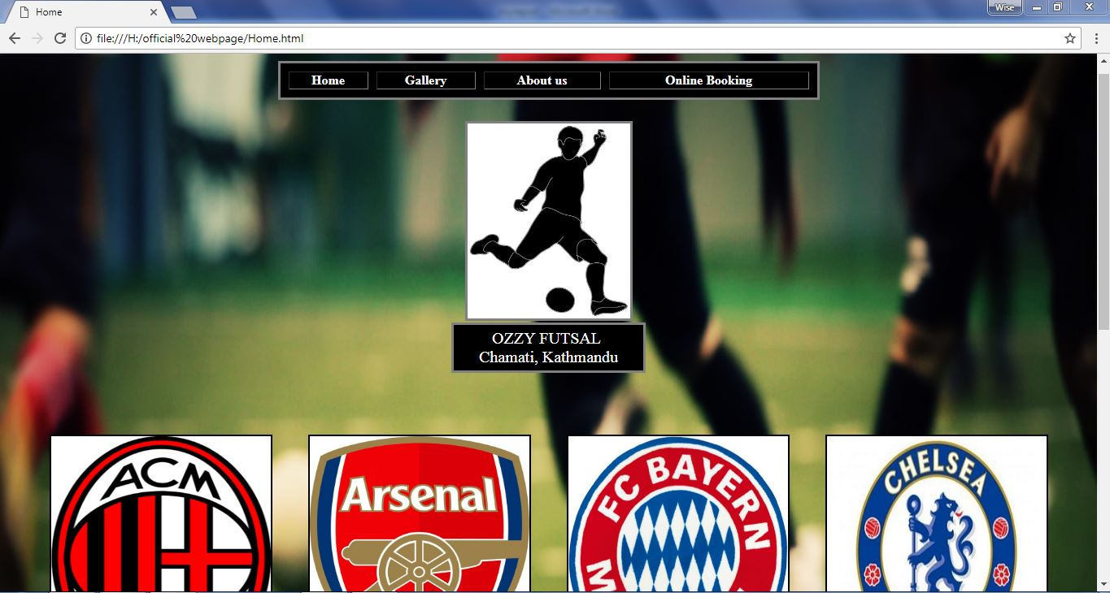

Figure 1 –Home page 1

## home2.JPG

Figure 2 –Home page 2

## GALLERY

<html>

<head>

<title> Gallery </title>

</head>

<body style="background-image: url(aboutus.jpg);background-size: 100% 100%;background-attachment: fixed;margin:0;">

<table style="margin-top: 2%;margin-bottom: 2%;border: 3px solid grey;" bgcolor="black" width="50%" border="2" align="center" cellspacing="10">

<tr>

<th><a style="text-decoration: none; color: white" href="Home.html">Home</a></th>

<th><a style="text-decoration: none; color: white" href="gallery.html">Gallery</a></th>

<th><a style="text-decoration: none; color: white" href="about us.html">About us</a></th>

<th><a style="text-decoration: none; color: white" href="online booking.html">Online Booking</a></th>

</tr>

</table>

<div align="center">

<img style="border: 3px solid grey;" src="lgo.jpg" alt="image of logo" height="240" width="200">

<!here the image file is in the same folder that contains the html file>

<p style=" width: 16.7898%; color: white;background-color: black;margin-top: 2; text-align: center;font-size: 20px;padding: 5px;border: 3px solid grey;">OZZY FUTSAL

<br> Chamati, Kathmandu</p><br>

</div>

<br>

<marquee width="34%" style="color: black;font-size: 30px;text-align: center;margin-left: 30%">

Welcome to Ozzy Futsal page

</marquee>

<div align="left" >

<h1> Grounds of Ozzy futsal</h1>

<img src="grounds.jpg" alt="image of ground" height="300" width="400" border="2" hspace="10" >

<img src="09.jpg" alt="image of ground" height="300" width="400" border="2" hspace="10">

<img src="booking.jpg" alt="image of ground" height="300" width="400" border="2" hspace="10">

<h2> Winner of the recent tournaments and their achievements </h2>

<img src="winners.jpg" alt="image of winners" height="300" width="460" border="2" vspace="20" hspace="20" >

<img src="trophy.jpg" alt="image of trophy" height="300" width="270" border="2" vspace="20" hspace="20">

<img src="medals.jpg" alt="image of trophy" height="300" width="460" border="2" vspace="20" hspace="20">

</div>

<div align="center">

<h3 align="center"> Direction <h3>

<img style="border: 3px solid grey;" src="direction.jpg" alt="image of map" height="400" width="600">

</div>

<div id="footer" style="text-align:right;color:black;">

<p>&copy; Copyright &copy; 2018. Company name all rights reserved</p>

</div>

<marquee width="25%" style="color: black;font-size: 30px;text-align: center;margin-left: 40%">

Sponsered by RED BULL

</marquee>

</body>

</html>

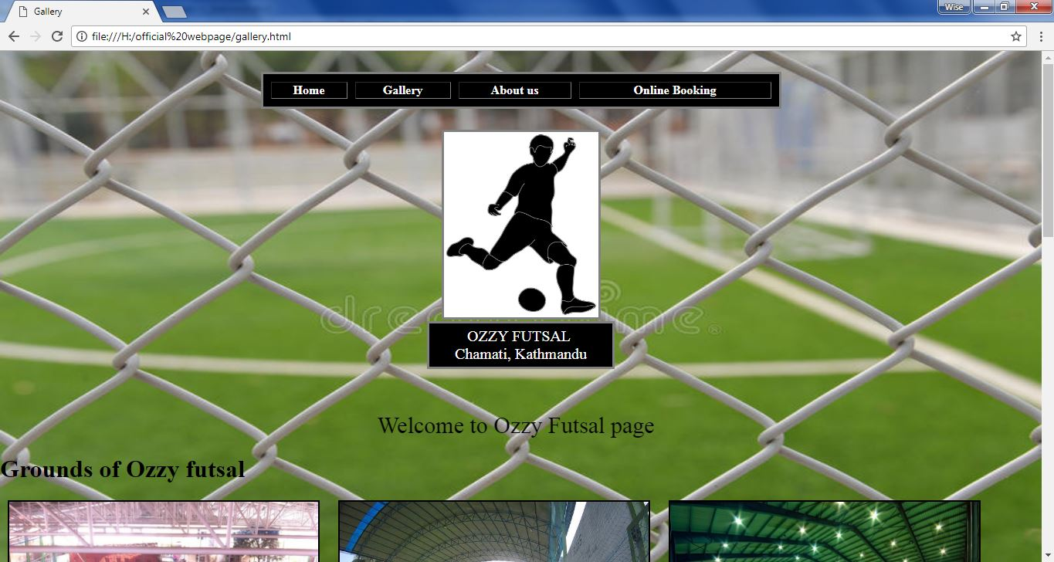

Figure 3 –Gallery 1

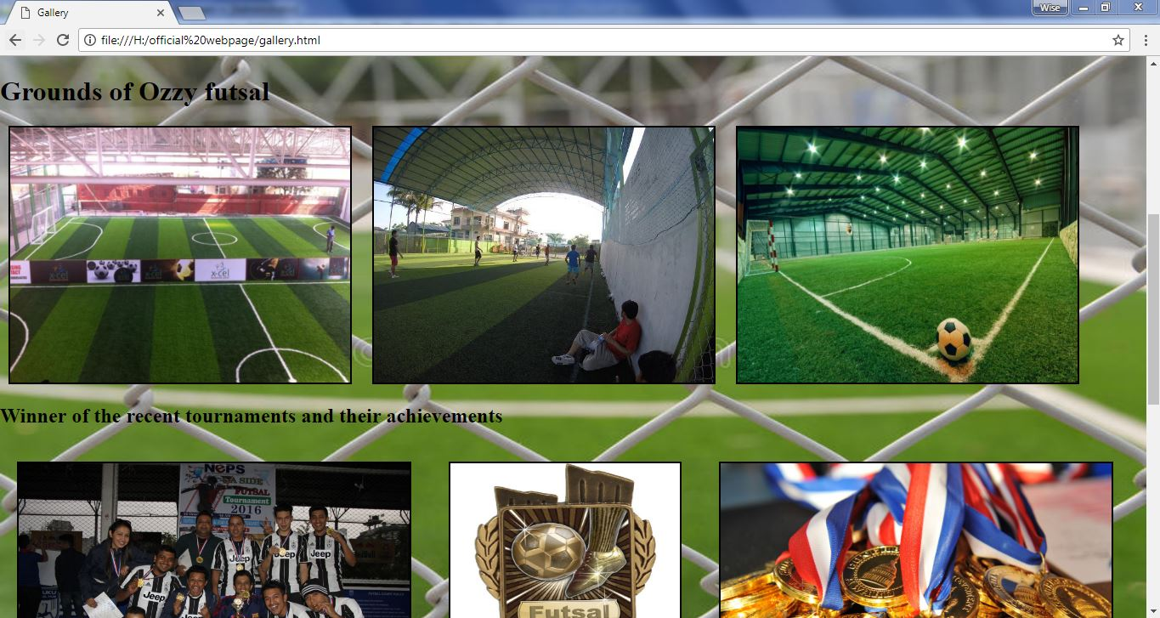

Figure 4 –Gallery 2

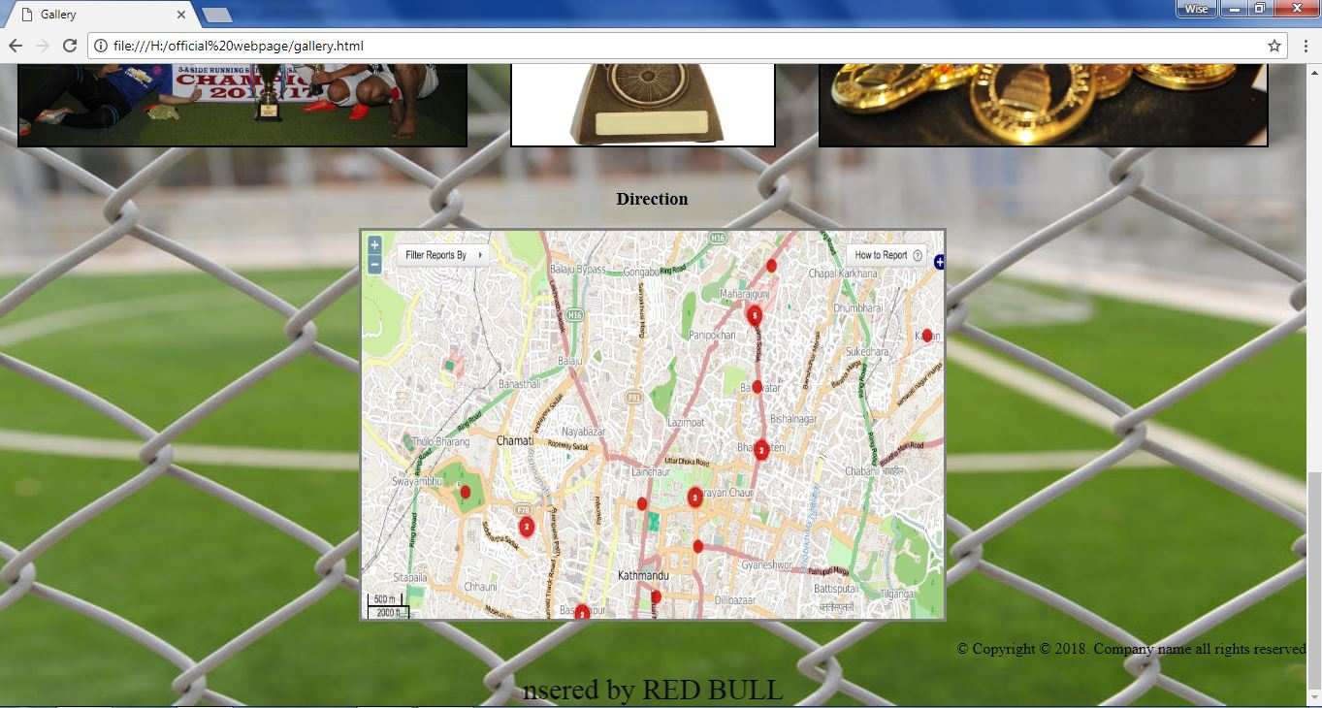

Figure 5 –Gallery 3

## ABOUT US

<html>

<head>

<title> About Us </title>

</head>

<body style="background-image: url(booking.jpg);background-size: 100% 100%;background-attachment: fixed;margin:0;">

<table style="margin-top: 2%;margin-bottom: 2%;border: 3px solid grey;" bgcolor="black" width="50%" border="2" align="center" cellspacing="10">

<tr>

<th><a style="text-decoration: none; color: white" href="Home.html">Home</a></th>

<th><a style="text-decoration: none; color: white" href="gallery.html">Gallery</a></th>

<th><a style="text-decoration: none; color: white" href="about us.html">About us</a></th>

<th><a style="text-decoration: none; color: white" href="online booking.html">Online Booking</a></th>

</tr>

</table>

<div align="center">

<img style="border: 3px solid grey;" src="lgo.jpg" alt="image of logo" height="240" width="200">

<!here the image file is in the same folder that contains the html file>

<p style=" width: 16.7898%; color: white;background-color: black;margin-top: 2; text-align: center;font-size: 20px;padding: 5px;border: 3px solid grey;">OZZY FUTSAL

<br> Chamati, Kathmandu</p><br>

</div>

<br>

<div align="center">

<p style="color: white;background-color: black;text-align: left;font-size: 24px; width: 90%;border-radius: 5%;padding: 2%;">

A brand new futsal centre has been opened in Chamati, Kathmandu. Ozzy Futsal And Recreation was inaugurated on August 8, 2015 and since then, it has been providing the platform for the enthusiasts of the sport. It has been serving promotional offers which include minimal charges of Rs 1000 per hour from 6:00 am to 5:00 pm and Rs 1300 per hour from 5:00 pm to 8:00 pm.

</p>

<p style="color: white;background-color: black;text-align: left;font-size: 24px; width: 90%;border-radius: 5%;padding: 2%;">

Futsal motivates players in an environment that is conducive to learning. The more pleasure kids find from their participation, the more they wish to play and practice on their own. While their instinct to play is natural, their appreciation for soccer must be nurtured. Futsal is very much a game in its own right,there are also a number of benefits for football by encouraging young people to play Futsal as part of a balanced training programme to improve their overall technical development.

</p>

<p style="color: white;align:left">

<a>Visit Us</a></p>

<p style="color: white;align:left">

info@ozzysal.com \ Tel: 224-426-6840

</p style="color: white;align:right">

<p>

<a href="entry.html" target="_blank">See Direction</a>

</p>

</div>

<marquee width="25%" style="color: white;font-size: 30px;text-align: center;margin-left: 40%">

Sponsered by RED BULL

</marquee>

</body>

</html>

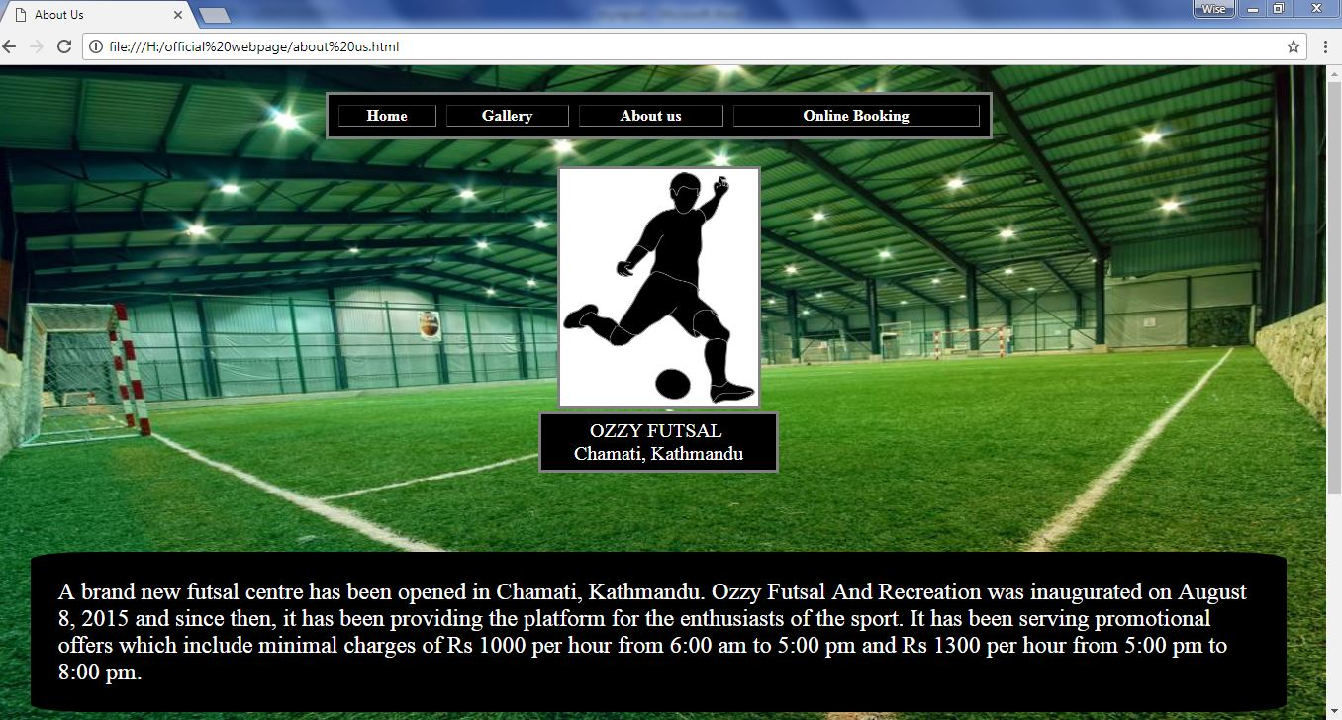

Figure 6 –About us 1

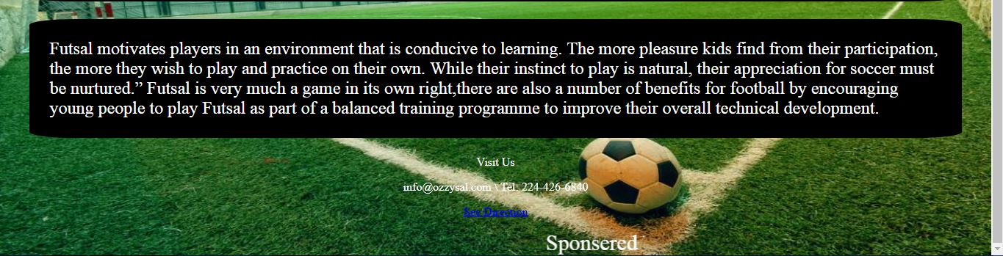

Figure 7 – About us 2

## ONLINE BOOKING

<html>

<head>

<title> Online booking</title>

</head>

<body background="boking.jpg" style="background-size: 100% 100%; background-attachment: fixed;">

<table style="margin-top: 2%;margin-bottom: 2%;border: 3px solid grey;" bgcolor="black" width="50%" border="2" align="center" cellspacing="10">

<tr>

<th><a style="text-decoration: none; color: white" href="Home.html">Home</a></th>

<th><a style="text-decoration: none; color: white" href="gallery.html">Gallery</a></th>

<th><a style="text-decoration: none; color: white" href="about us.html">About us</a></th>

<th><a style="text-decoration: none; color: white" href="online booking.html">Online Booking</a></th>

</tr>

</table>

<div align="center">

<img style="border: 3px solid grey;" src="lgo.jpg" alt="image of logo" height="240" width="200">

<!here the image file is in the same folder that contains the html file>

<p style=" width: 16.7898%; color: white;background-color: black;margin-top: 2; text-align: center;font-size: 20px;padding: 5px;border: 3px solid grey;">OZZY FUTSAL

<br> Chamati, Kathmandu</p><br>

</div>

<br>

<form method="POST" action="" width="440" height="220" >

<fieldset style="background: url(2wo gnd-01.jpg);">

<legend align="left" style="color: white;">Information</legend>

<p style="color: white;">Full Name:<input type="text" size=40 name="myname"></p><br>

<p style="color: white;">Address:<input type="text" size=20 name="addr"></p><br>

<p style="color: white">Contact number:<input type="text" size="20" name="number"></p><br>

<p style="color: white">Ground:<input type="radio" value="A" name="ground">A

<input type="radio" value="B" name="ground">B</p> <br>

<p style="color: white">Time:<input type="time" size="10" name="time"></p>

</fieldset>

<br>

<fieldset>

<p style="color: white;">Payment:<input type="checkbox" value="Online" name="ch1">Online Payment

<input type="checkbox" value="after match payment" name="ch2">After Match Payment</p> <br>

<p style="color: white">Match Type:

<select name="type">

<option value="Friendly">Friendly</option>

<option value="looser pay">Looser Pay</option>

<option value="40-60">6:4</option>

<option value="70-30">7:3</option>

</select></p>

<p style="color: white;">Your Comments:<br>

<textarea rows=5 cols=40 >

</textarea>

</p>

<input type="submit" value="Send">

<input type="reset" value="Clear">

</fieldset> <br><br>

<fieldset>

<input type="submit" value="Confirm" name="Confirm">

<input type="reset" value="Reset" name="Reset">

</fieldset>

</form>

</body>

</html>

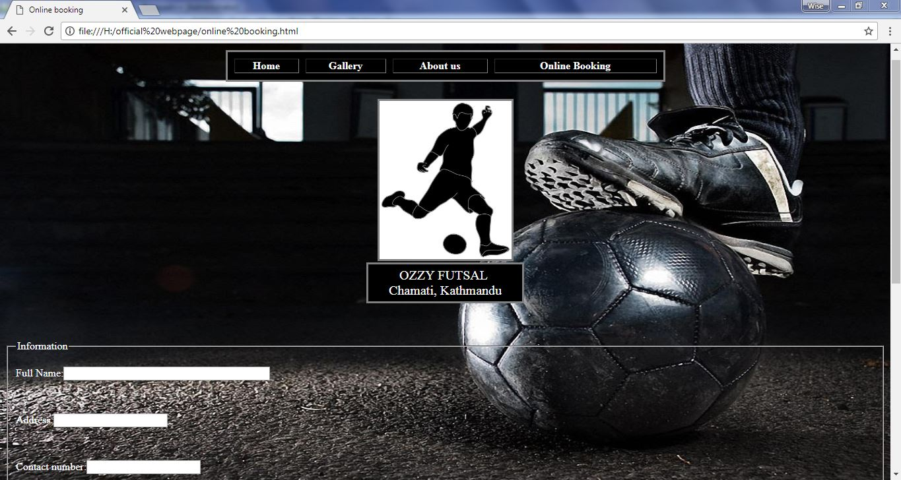

Figure 8 Booking 1

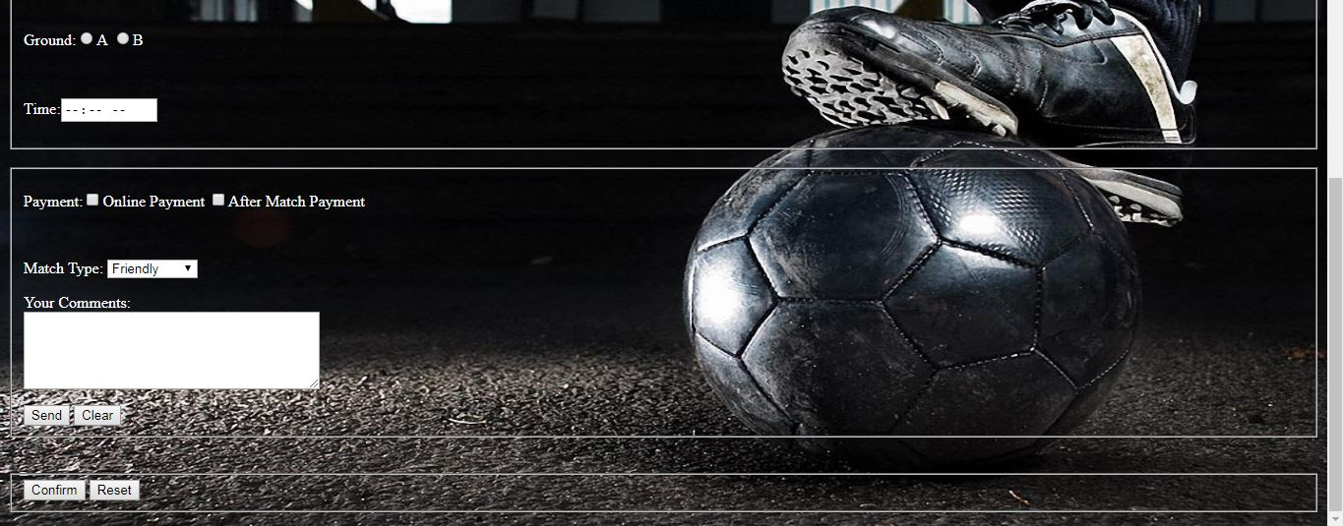

Figure 9 – Booking 2

# CONCLUSION:

Hence, the project work gives information about the HTML in detail and the types of tags and the ways to use those tags. Through the help of this project we were able to understand the meaning of HTML and the types of tags and the proper way of using those tags to create webpage and design it in an attractive way that can catch the eye of the user very easily.

Thus, through this project we were able to gain more knowledge about creating a webpage and the process used to create it. So, I would like to thank our computer teacher once again for assigning us this project and giving us the chance of acknowledging our skills through this project.

**Refrence**

* Course book
* Internet
* Subject Teacher
* Seniors